Create PDF On ITextSharp

1. First Download the DLL file ITextsharp to create the pdf file

and Add the DLL in Reference then use it in our project

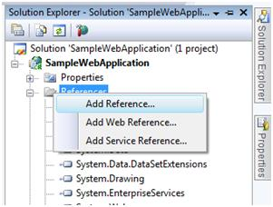

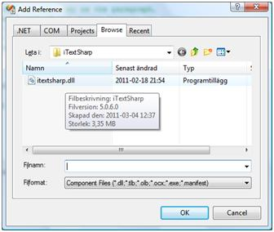

1. Add the Following Library in our Project

using iTextSharp;  
using iTextSharp.text;  
using iTextSharp.text.pdf;

1. we create a Filestream object to representing a file and

By using the MapPath we target the folder

System.IO.FileStream fs = new FileStream(Server.MapPath("pdf") + "\\" + "First PDF document.pdf", FileMode.Create)

1. Create the class Document and pass the page size and margin

of pdf document

Document document = new Document(PageSize.A4, 25, 25, 30, 30);

1. File stream to create the pdf writer to set the pdf Document

PdfWriter writer = PdfWriter.GetInstance(document, fs);

1. Before we can write to the document we need to open it.

document.Open();

1. Then write the Html content into the Document.

document.Add(new Paragraph("Hello World!"));

1. Then Close the Document.

document.Close();

Sample code:

using (MemoryStream ms = new MemoryStream())

{

   Document document = new Document(PageSize.A4, 25, 25, 30, 30);

   PdfWriter writer = PdfWriter.GetInstance(document, ms);

   document.Open();

   document.Add(new Paragraph("Hello World"));

   document.Close();

   writer.Close();  
   Response.ContentType = "pdf/application";

   Response.AddHeader("content-disposition",   
   "attachment;filename=First PDF document.pdf");

   Response.OutputStream.Write(ms.GetBuffer(), 0, ms.GetBuffer().Length);

}